Kirchhoff’s Lab Report
Student’s Name
Submission Date

.
OBJECTIVE
The main aim of the experiment was to investigate what type of a circuit to which Kirchhoff’s rules must be applied. It was also required that, one to apply Kirchhoff’s rules to several circuits and solve for the currents in the circuit, and compare between the theoretical value of the predicted by Kirchhoff’s rule to that of the theoretical values.

Equipment list
- Direct current voltmeter (digital, 0-1000 Ma) direct ammeter current (digital, 0-1000Ma)
- Two sources of EMF (direct power supplies of up to 12v)
- Three or four resistors range 500-100 ohms
- Digital ohmmeter for one of the class connecting wires.

THEORY

Consider the circuit in Figure 34-1. The circuit is labeled with all of the currents. The 2 Q resistor, 8Q resistor, and 12 V power supply have current 11, the 6Q resistor has current 12, and the 3Q resistor has current 13. This circuit is called a single-loop circuit because it can be reduced to a single resistor in series with the power supply. The 6 Q resistor and the 3 Q resistor are in parallel with an equivalent resistance of 2 Q. That equivalent 2 Q resistance is in series with the 12 V power supply and the other two resistors, reducing the circuit to a single-loop circuit. The total resistance across the 12 V power supply is 12 Q and its current is therefore 11 = 1 A. Applying Ohm's law to the remaining part of the circuit gives 12 and 13 = 2/3 A.
Consider now the circuit of Figure 34-2. This laboratory is concerned with the fundamental difference between circuits of the type depicted in Figure 34-1 and circuits of the type depicted in Figure 34-2. The circuit in Figure 34-2 cannot be reduced to a single-loop circuit, but instead is called a multi-loop circuit. Before analyzing this circuit, first we will define some terms. A point at which at least three possible current paths intersect is defined as a junction. For example, points A and B in Figure 34-2 are junctions. A closed loop is any path that starts at some point in a circuit and passes through elements of the circuit (in o this case resistors and power supplies), and then arrives back at the same point without passing through any circuit element more than once

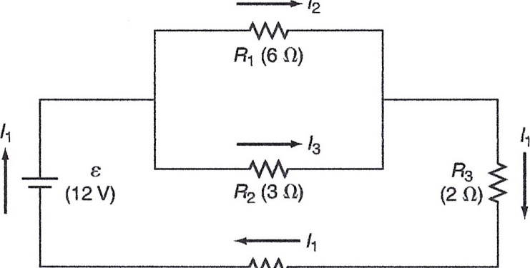
12

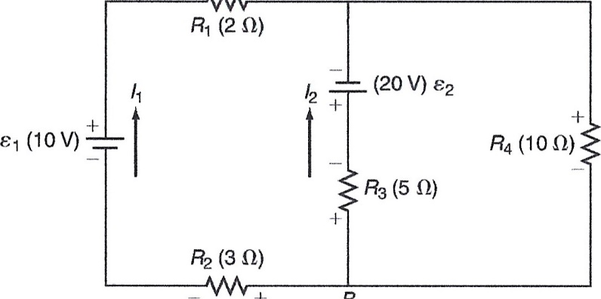
13
-1-

The solution for the currents in a multi-loop circuit uses two rules developed by Gustav Robert Kirchhoff. The first of these rules is called Kirchhoff's current rule (KCR). It can be stated in the following way:
KCR—The sum of currents into a junction the sum of currents out of the junction.
This rule actually amounts to a statement of conservation of charge. In effect it states that charge does not accumulate at any point in the circuit. The second rule is called Kirchhoff's voltage rule (KVR). It can be stated as:
KVR—The algebraic sum of the voltage changes around any closed loop is zero.
This rule is essentially a statement of the conservation of energy, which recognizes that the energy provided by the power supplies is absorbed by the resistors.
In a multi-loop circuit, the values of the resistors and the power supplies are known. It is necessary to determine how many independent currents are in the circuit, to label them, and then to assign a direction to each current. Application of Kirchhoff's rules to the circuits, treating the assigned currents as unknowns, will produce as many independent equations as there are unknown currents. Solving those equations will determine the values of the
In the application of KVR to a circuit, take care to assign the proper sign to a voltage change across a particular element. The value of the voltage change across an EMF can be either +8 or —e depending upon which direction it is traversed in the loop. If the EMF is traversed from the (—) terminal to the (+) terminal, the change in voltage is +6. However, when going from the (+) terminal to the (—) terminal, the change in
voltage is —e. In the laboratory we will measure the terminal voltage of the sources of EMF. We will assume that those values approximate the EMF.
When a resistor R with an assumed current I is traversed in the loop in the same direction as the current, the voltage change is —IR. If the resistor is traversed in the direction opposite that of the current, the voltage change is -FIR. The sign of the voltage change across an emf is not affected by the direction of the current in the emf. The sign of the voltage change across a resistor is completely determined by the current direction.
Consider the application of Kirchhoff's rules to the multi-loop circuit of Figure 34-2. At the junction A current 11 and 12 go into the junction, current 13 goes out of the junction, and KCR states
11 +12 13
It might appear that applying KCR to the junction B would produce an additional useful equation, but in fact it would result in an equation that is identical to Equation 1.
Applying KVR to the loop that starts at B, goes through the 10 V power supply to A, and then down through the 20 V power supply back to B, gives the following equation with values of the resistances included.
— R2 Il + El — RI Il + E2 + R3 12 O or —311 + 10 — 211 20 5 12 0 (Eq. 2)
The signs used in Equation 2 and the circuit diagrams are consistent with the description given above for determining the signs of voltage changes. Applying KVR to the loop that starts at B and goes clockwise around the right side of the circuit gives

-R312 -€2-1013 -O or -512-20-1013 =0
Equations 1, 2, and 3 are the three needed equations for the three unknowns Il, 12, and 13. The solution of these equations gives values for the currents of 11 2.800 A , I 2--3.200A, — and 13-- — 0 .400 A. The currents 12 and 13 are negative. This indicates that the original assumption of direction for these two currents was incorrect. The interpretation of the solution is that there is a current of 2.800 A in the direction indicated in the figure for 11, a current of 3.200 A in a direction opposite to that indicated in Figure 34-2 for 12, and a current of 0.400 A in a direction opposite to that indicated for 13. This is a general feature of solutions using Kirchhoff's rules. Even if the original assumption of the direction of a current is wrong, the solution of the equations leads to the correct understanding of the proper direction by virtue of the sign of the current

EXPERIMENTAL PROCEDURE
- The values that were used were close to the actual values that were given that is R1=500ohms R2=750ohms, R3=1000ohms. The value of the resistors were recorded and measured in table one
- Two power supplies were used in this experiment and three resistors R1, R2 and R3. As shown below with emf of 10.0v and 5.0v respectively
- Current’s I1, I2 and I3 were measured.

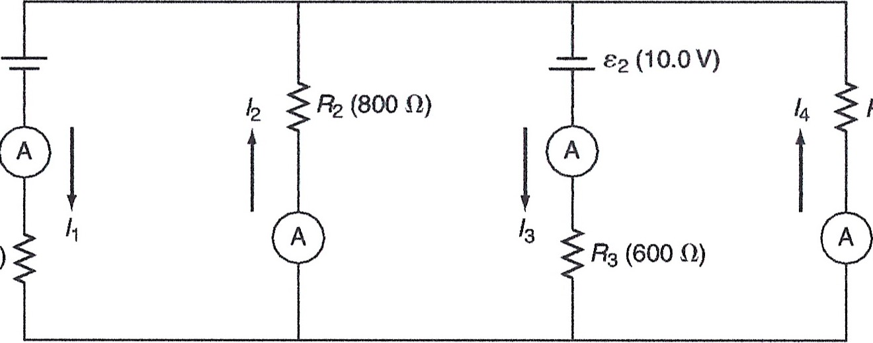
(5.00V)
RI
(1000
Q)
R4
(500
0)

Experimental multi-loop circuit with four unknown currents.
- EMF 1 and 2 were measured with a voltmeter and the recordings were recorded using an ammeter and filled in table 1=
- The circuit of fig above with 4 loops was constructed and it also was supplied to two power supplies and 4 resistors. the values of EMF that were chosen were 5v and 10v respectively. Resistor 1= 1000ohms R2=800 ohms R3=600 OHMS AND R4=500ohms. Determine and record in data table 2 the values of resistors and currents of the four values.

Calculations.
1 DATA Table 1
Power supply voltages

Emf 1=

Emf2=

Resistor values in ohms | Experimental current mA
R₁=553.3 | I₁ = 7.881
R₂=683.4 | I₂=1.463
R₃=982.0 | I₃=6.330

Calculation table 1
Kirchhoff’s rule for the circuit
(1) KCR-
(2) KVR1-
(3) KVR2-
THEORETICAL CURRENT  (Ma0 | %error experimental to theoretical current
I₁=6.45 | 22.2%
I₂=1.45 | 0.85%
I₃=7.80 | 18.8%

PRE-LABORATORY ASSIGNMENT
- The circuit is a single loop circuit, since you can combine the two resistor which are parallel to form one resistor.
Assuming R₁ and R₂ WERE KNOWN THE CURRENTS COULD be determined without the use of Kirchhoff’s rule

- I₃=I₂-I₁
2.00-0.75=1.25Ohms

3 equivalent resistance
¼+1/4= 2/4
Which is equivalent to ½ doing the reciprocal the resitance will be 2
Equivalent resistance=2+3+5=10ohms
4 current at 5 ohms resistor
5/10= 0.5amps.
5 the three equations are
I₁+I₂=I₃
10I₂+10-5I₂=0
-10I₂+15-15I₃=0
- SOLVING FOR THE ABOVE EQUATIONS, I WAS ABLE TO GET THE FOLLOWING VALUES.
I₁=1.45AMPS
I₂=-0.85AMPS
I₃ =0.95AMPS
- The minus sign shows that the resistor R with current I was trans-versed in the loop in the
same direction as the current, the voltage change’s is -IR.

Sample calculations
- I₁=I₂+I₃
-750I₂+(10-500) I₂=0
750I₂ +(5-100) I₃=0
The above equations gave as I₁, I₂ AND I₃ respectively.
- I₄=I₁+I₂+I₃
-800I₂+(5-100) I₁=0
800I₂+(10-600) I₃=0
600I₃+(10-500) I₄=0

QUESTIONS

- THE equation that relates I₁,1₂ AND I₃ IS
I₁=I₂+I₃
1.45+6.45=7.90ampers for the theoretical value
7.881+1.463=9.344amperes for the experimental.
%error=9.344-7.90/9.344=15.45%

- They are smaller and some larger than the actual this may be due to some errors that may arise during the experimentation stage or during calculation of the theoretical value.
- Yes. Since some of the deviations are minimal it may have risen from the ammeter resistance that may have some consumed some current. This resistance may lead to some current being lost due to the ammeter resistance.
- Yes it may also have caused the error. The resistance that may be experienced due to the compactness of the atoms in the wire may lead to a decrease in current. Since less current will reach the other end. The higher the resistance the less current will pass through it.

Conclusion
The objective of the experiment was achieved the errors arising may have occurred due to human error or the equipment. Systematic or as systematic error may have caused the deviation of the results.

